LE BANG BANG

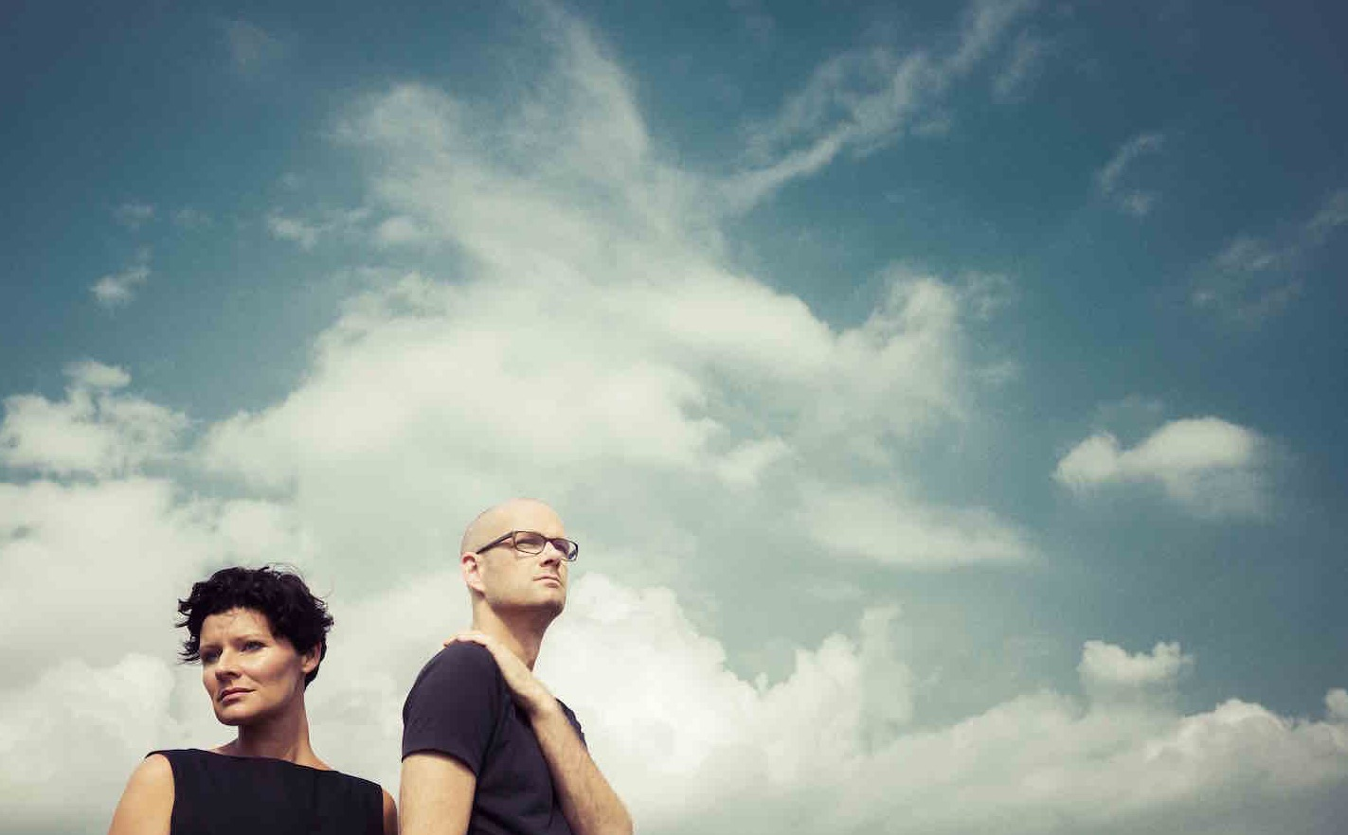

„With ingenuity, devotion and sizzling suspense – magnificent!
LICHTUNG

„The First League.“
ELLE

„What a richness of sounds and colors. A real firecracker. Bang!”
BAYERISCHER RUNDFUNK

„Stefanie Boltz and Sven Faller know how to create suspense and they succeed at keeping it up for a whole night. These are not just cover versions of jazz and pop by an extraordinary duo, their arrangements extract the pure essence of the composition.”
SÜDDEUTSCHE ZEITUNG

„A success from beginning to end. The huge bass sound is just as imposing as astounding versatility and flexibility of the voice”
JAZZTHETIK
Le Bang Bang strip their song material of any unnecessary baggage, until it almost crackles between the notes. Armed with just a voice and a bass, Stefanie Boltz and Sven Faller have ventured into stepping onto any stage of any size for six years now. The result is a gripping balancing act in which every nuance matters and is able to make the whole thing turn into an unexpected direction. The stunned audience looks on as the two musicians feed each other lines out of the moment. Sometimes he might take a familiar song classic for one of Le Bang Bang’s imaginative original compositions when the two do their thing. Consequently, the duo chose to bare all for the cover artwork of their new album “Pure” - as pure as they prefer their music. To closely capture the intimacy of their live performances, Boltz and Faller recorded directly on stage during their 2016 tour - mostly after the applause had faded and the audience was gone...

fine artist booking & artist management
Stefanie Boltz
mail@fine-artist.de
call: +49 (0) 178 3999339
www.lebangbang.de

